**Data Science WorkBook**

I have included working copies of the **jupyter notebook** and python(.py) files of a data science workbook that I have worked on over the past few years to structure our data analysis process and best methods to execute on data. Including importing multiple data types(XML, JSON, CSV, MySQL,etc…)

If you would like to use this in the cloud on Google Collab please follow the link below and then make a copy to your Google drive to work with the code. You must make a copy this link is only shared to view and does not save.

**Google Collab URL:** <https://colab.research.google.com/drive/1POAqqrgNWpYCI2MGThBPJf_vU7bvCtbN>

**Instructions:**

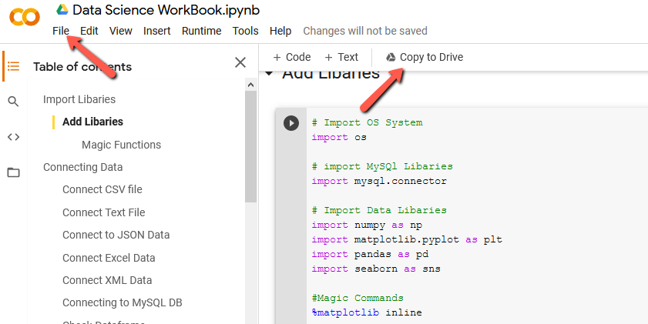

You can also send a pull request on my github to contribute and add to this notebook. Making it a useful tool full of code snippets and resources.

**Github Link:**

<https://github.com/shaungt1/DataScience_Workbook.git>